2. ANALYSIS AND REQUIREMENTS
2.1 Problem Analysis
In the digital era, online encyclopedias provide extensive information on various academic topics. However, lengthy articles, complex terminology, and excessive details can make it difficult for users to identify and understand important information. Students may also spend considerable time preparing summaries, revision notes, and flashcards manually. Furthermore, users with visual impairments, dyslexia, or a preference for auditory learning may face difficulties when using conventional text-based platforms.
AKIRA (Accessible Knowledge & Information Retrieval Assistant) aims to address these challenges by providing a user-friendly platform for retrieving and understanding information. It retrieves articles from Wikipedia and presents the content through concise summaries, key takeaways, and interactive flashcards. The application also provides voice search, text-to-speech, synchronized sentence highlighting, accessibility settings, bookmarks, search history, and document export facilities.
2.2 Existing System
The existing system involves searching for information on online encyclopedias and manually reading lengthy articles. Users must identify important concepts themselves and prepare study materials separately. Conventional approaches may also lack integrated voice interaction, personalized reading settings, and convenient tools for organizing and exporting learning materials.
2.3 Proposed System
AKIRA is a web-based application developed using Python, Flask, HTML, CSS, JavaScript, and SQLite. It retrieves encyclopedic information through the Wikipedia API and processes it into simplified learning materials. The system supports voice-based searching, audio-assisted reading, dyslexia-friendly typography, adjustable text sizes, dark and light themes, and academic content filtering. It also allows users to save bookmarks, review search history, and export study materials as PDF and Markdown files.
The proposed system aims to make information retrieval more accessible, interactive, and useful for academic learning.
2.4 UML Analysis Model
Unified Modeling Language (UML) is used to represent the functionality and workflow of the AKIRA application. The following diagrams illustrate the interaction between users and the system.
2.4.1 Use Case Diagram
The use case diagram represents the main activities performed by a user while interacting with AKIRA.

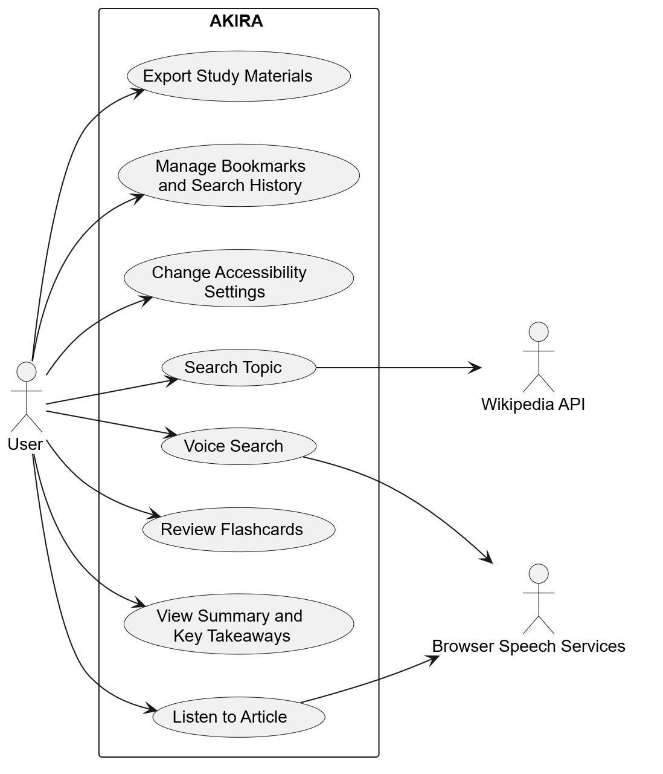

Explanation: The diagram shows how users search for topics, view processed content, review flashcards, use voice features, adjust accessibility settings, manage saved information, and export study materials. The Wikipedia API provides article information, while browser speech services support voice interaction and audio playback.
2.4.2 Activity Diagram
The activity diagram describes the main workflow followed when a user searches for information using AKIRA.
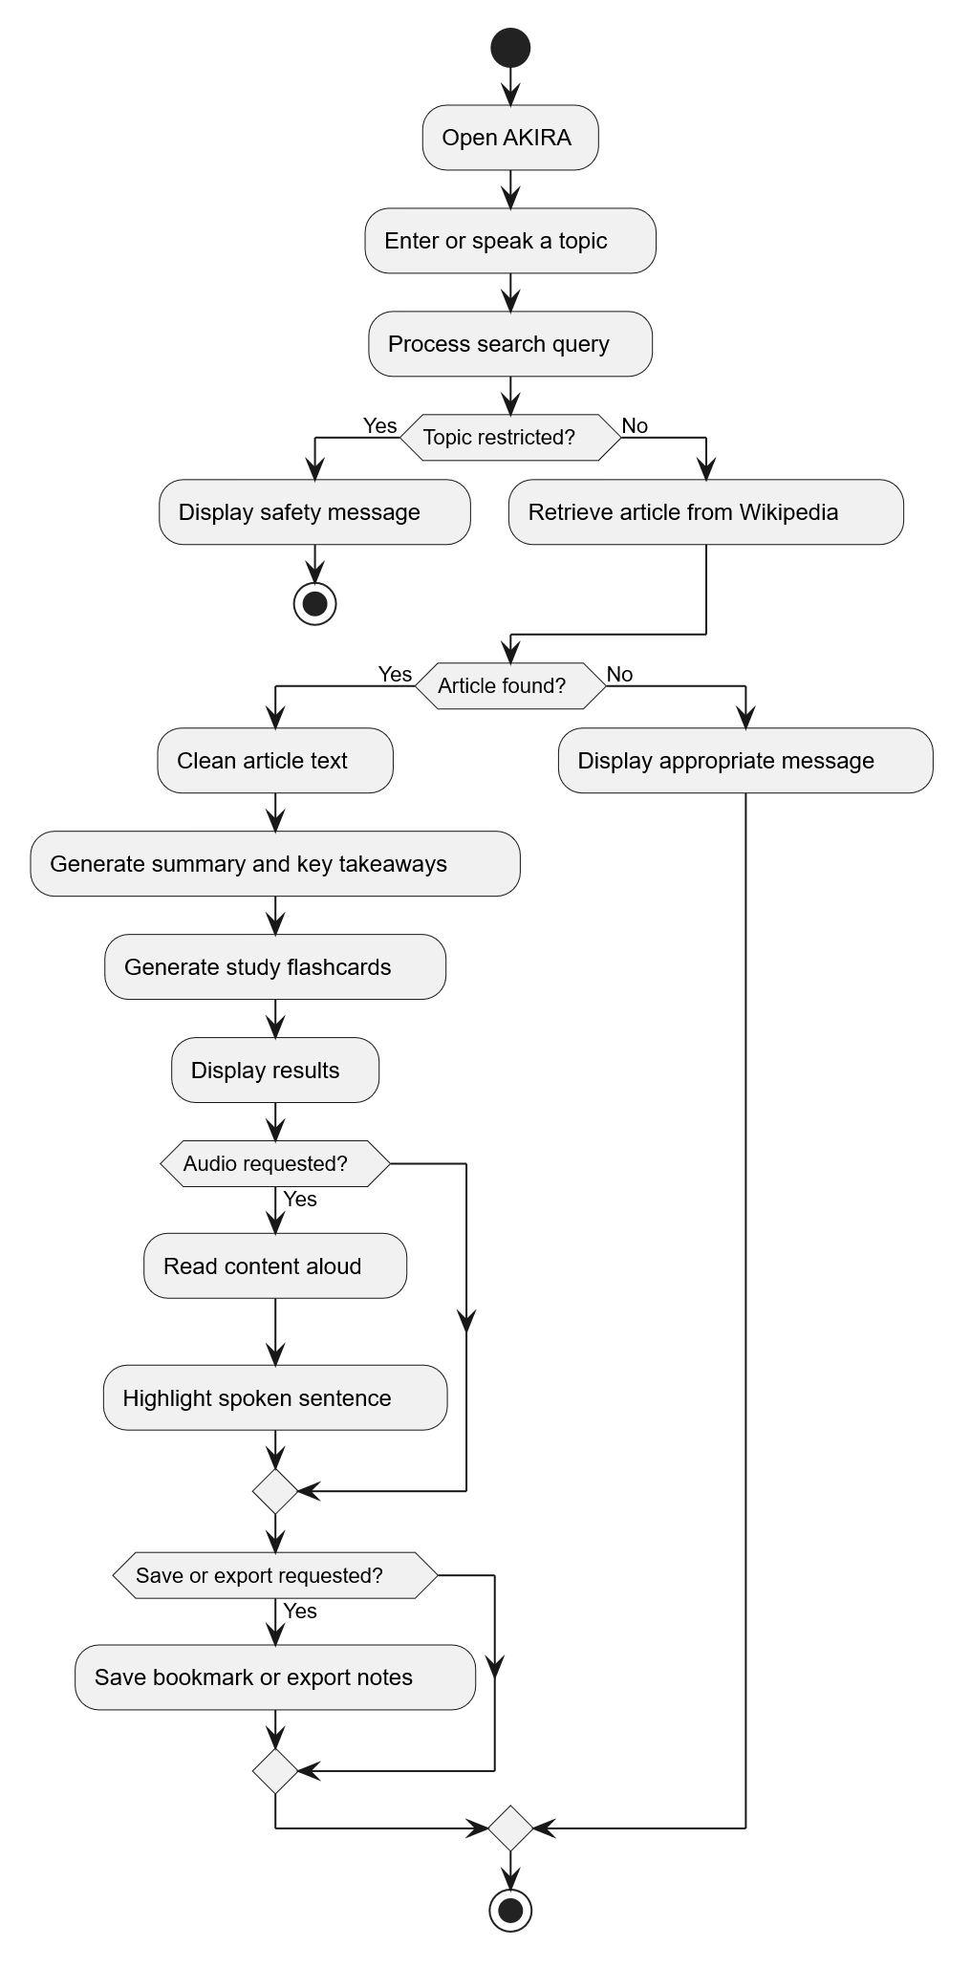
Explanation: The workflow begins when the user enters or speaks a topic. AKIRA processes the query and checks it against the academic content filter before retrieving the article. If the article is available, the system generates learning materials and displays the results. Users can then listen to the content, save bookmarks, or export study notes.
2.5 System Requirements
The system requirements define the main functions and operational characteristics of AKIRA.
2.5.1 Functional Requirements
The system should:
- Retrieve encyclopedic information from Wikipedia based on user queries.
- Generate concise summaries, key takeaways, and interactive study flashcards.
- Support voice search and text-to-speech functionality.
- Provide synchronized sentence highlighting during audio playback.
- Offer accessibility features such as dyslexia-friendly fonts, adjustable text sizes, and dark and light themes.
- Maintain search history and bookmarks using an SQLite database.
- Apply academic content filtering and intelligent query resolution.
- Allow users to export study materials in PDF and Markdown formats.
2.5.2 Non-Functional Requirements
- Usability: The interface should be simple and easy to navigate.
- Accessibility: The application should support different reading and learning preferences.
- Reliability: The system should handle invalid queries and retrieval errors appropriately.
- Maintainability: The application should use modular components for easier development and modification.
- Cost-effectiveness: The system should rely on free and open-source technologies without paid third-party API dependencies.
- Compatibility: The application should work in modern browsers, subject to browser support for speech features.
2.6 Hardware and Software Requirements
Hardware Requirements
- Desktop computer or laptop.
- Adequate RAM and storage to run the application and its dependencies.
- Microphone for voice search.
- Speakers or headphones for audio playback.
Software Requirements
Component | Technology
Programming language | Python 3
Backend framework | Flask
Frontend | HTML5, CSS3, JavaScript
Database | SQLite
Information source | Wikipedia/Wikimedia API
Speech services | Browser Web Speech API
PDF generation | ReportLab
Testing framework | Python unittest
2.7 Summary
The analysis identifies the limitations of conventional information retrieval systems and establishes the requirements for developing AKIRA. The proposed system integrates information retrieval, accessible reading, voice interaction, automated study materials, and data persistence into a single web application. The UML diagrams describe the main user interactions and application workflow, providing a foundation for the subsequent design, implementation, and testing phases.

